# Iteration 1

Goal of the iteration: HTML elements are dynamically generated using JavaScript.

|  |  |  |  |
| --- | --- | --- | --- |
| Planned Tasks | Product | Estimated Time | Actual Time |
| Plan | This | 10m | 20m |
| Analyse | Methods of implementation compared – research HTML DOM elements | 10m | 5m |
| Design | Prepared for coding  Wireframe drawn up | 20m | 15m |
| Code | Buttons that show specific content  Previous content is cleared before new content is displayed | 1h | 2h |
| Test | Code works without major errors | 20m | 30m |

# Site Wireframe

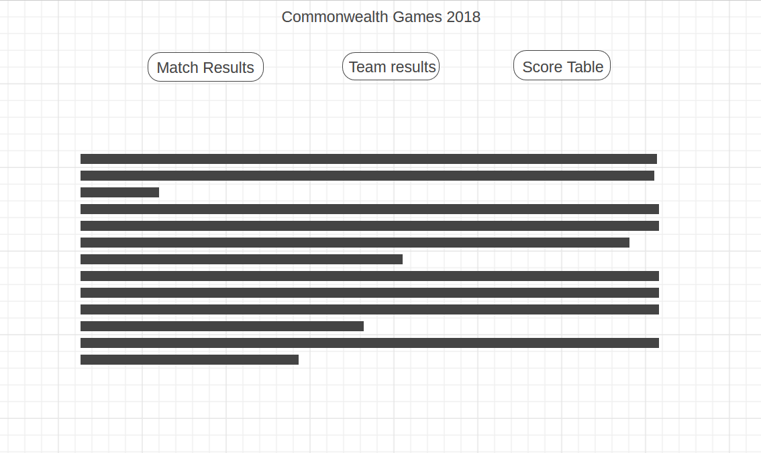

# Evaluation



StandardJS runs without finding errors.

## Mistakes

One mistake I made was spending too much time trying to figure out how to even start the iteration, initially planning to ‘make it pretty’. Because of this I lost valuable time. Next time I can make sure to start with a good structure and understanding so that I can be more productive.